Experiment: 3
Student Name: Habis Prakash Deka UID:24BDA70031
Branch: CSE Section/Group: AIT-KRG-GP2
Semester: 4th Date of Performance:7/01/28
Subject Name: DBMS

Aim of the practical:

To understand the basic structure of a PL/SQL program by creating and executing a simple PL/SQL block that includes declaration and execution sections, and to display output using built-in procedures.

Tool Used:

● Database Management System:

Oracle Database

Objective:

To create a simple PL/SQL program demonstrating Declaration Section and Execution Section.

Practical / Experimental Steps

Step 1: Open Oracle SQL*Plus / SQL Developer and create a new SQL worksheet.
Step 2: Enable output display using the command: SET SERVEROUTPUT ON.
Step 3: Write the first PL/SQL block with a DECLARE section to define employee variables.
Step 4: Execute the block using BEGIN…END and display values using DBMS_OUTPUT.PUT_LINE.
Step 5: Run the second and third blocks to perform salary calculations and conditional tax bracket checks.
Step 6: Observe and verify the output results shown in the output window for each PL/SQL block execution

- Declaration Section
DECLARE
emp_id NUMBER := 101;
emp_name VARCHAR2(50) := 'John Doe';
emp_salary NUMBER := 90000;

- Execution Section

BEGIN
DBMS_OUTPUT.PUT_LINE('Employee ID : ' || emp_id);
DBMS_OUTPUT.PUT_LINE('Employee Name : ' || emp_name);
DBMS_OUTPUT.PUT_LINE('Employee Salary : ' || emp_salary);
END;
/

I / O Analysis
DECLARE
emp_id NUMBER := 101;
emp_name VARCHAR2(50) := 'John Doe';
emp_salary NUMBER := 90000;
BEGIN
DBMS_OUTPUT.PUT_LINE('Employee ID : ' || emp_id);
DBMS_OUTPUT.PUT_LINE('Employee Name : ' || emp_name);
DBMS_OUTPUT.PUT_LINE('Employee Salary : ' || emp_salary);
END;
/
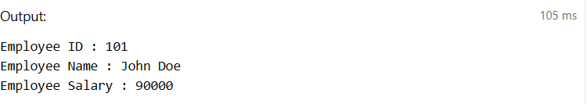

DECLARE
emp_salary NUMBER := 50000;
result NUMBER;
BEGIN
DBMS_OUTPUT.PUT_LINE('Mathemathical Operations on salary ');
result := emp_salary * 0.01;
DBMS_OUTPUT.PUT_LINE('10% of salary :'|| result);
DBMS_OUTPUT.PUT_LINE('Salary After Promotion : ' || (emp_salary+result));
DBMS_OUTPUT.PUT_LINE('Salary Ater Demotion : ' || (emp_salary-result));
DBMS_OUTPUT.PUT_LINE('Salary per annum. :' || (emp_salary*12));
END;
/
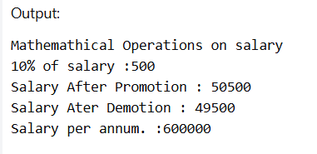

DECLARE
emp_salary NUMBER:= 60000;
package NUMBER;
BEGIN
DBMS_OUTPUT.PUT_LINE('Employee Tax Bracket (calculated based on salary only, real figures might differ) :');
package := emp_salary*12;
IF package<300000 then
DBMS_OUTPUT.PUT_LINE('Poor');
elsif package<800000 then
DBMS_OUTPUT.PUT_LINE('Still Poor but hopeful');
elsif package<1200000 then
DBMS_OUTPUT.PUT_LINE('Just avoiding tax');
elsif package>1200000 then
IF package<1500000 then
DBMS_OUTPUT.PUT_LINE('Just avoided tax-free life');
else
DBMS_OUTPUT.PUT_LINE('RICH');
end if;
end if;
END;
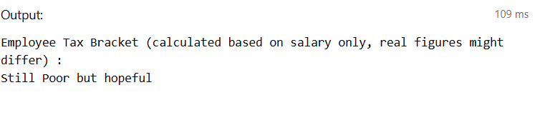

Learning outcomes (What I have learnt):
• Understood the basic structure of a PL/SQL block, including the DECLARE and BEGIN…END sections.
• Learned how to declare and initialize variables for storing data values.
• Gained knowledge of using DBMS_OUTPUT.PUT_LINE to display results during program execution.
• Practiced performing mathematical operations on variables within PL/SQL programs.
• Developed understanding of decision-making using IF–ELSIF–ELSE conditional statements.
• Acquired practical insight into how PL/SQL can be used for simple database-related computations and logic implementation.

